Less: Less is a command line utility that displays the contents of a file or a command output, one page at a time. It is similar to more, but has more advanced features and allows you to navigate both forward and backward through the file. Thelesscommand is mostly used for opening large files
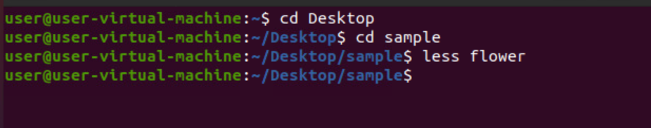
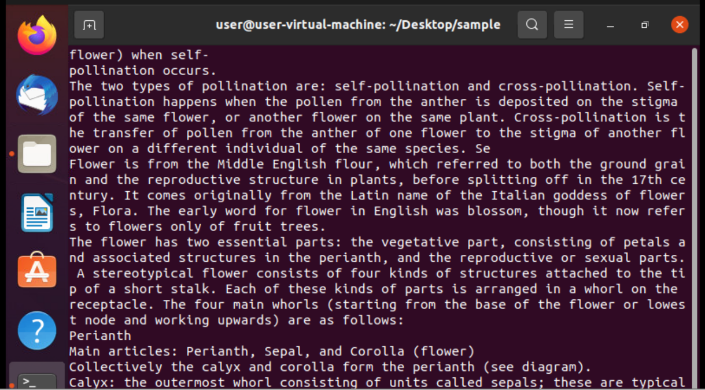

To quit less and go back to the command line press q

-p is used to search a particular word or string in the data
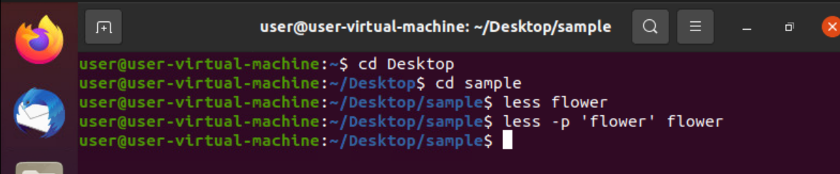

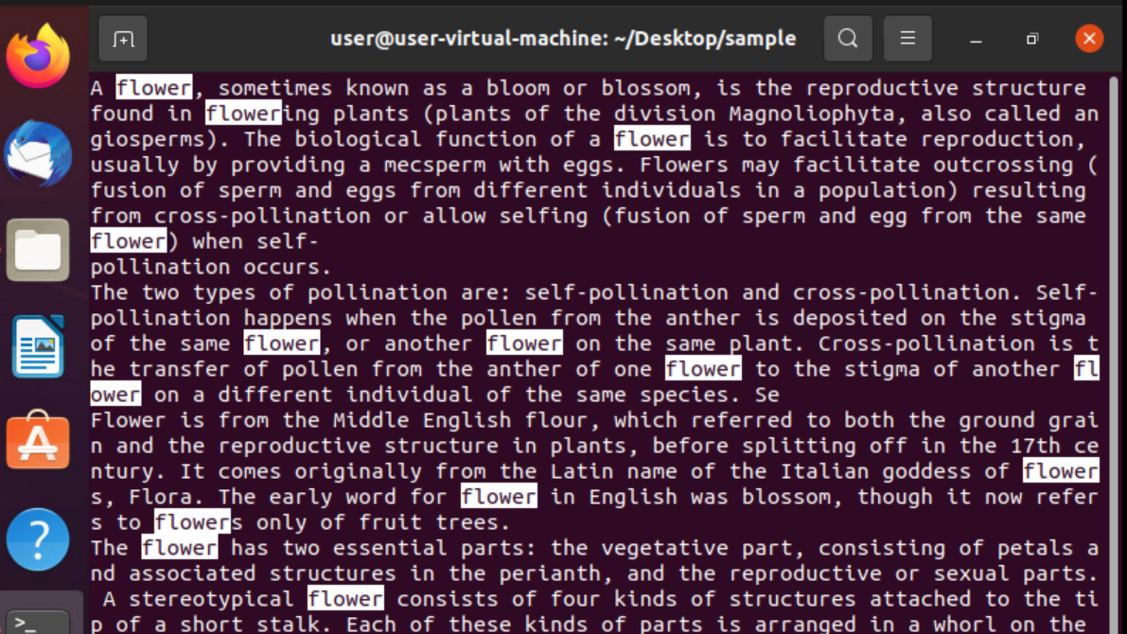

If you want less to shows line numbers launch the program with the -N option:
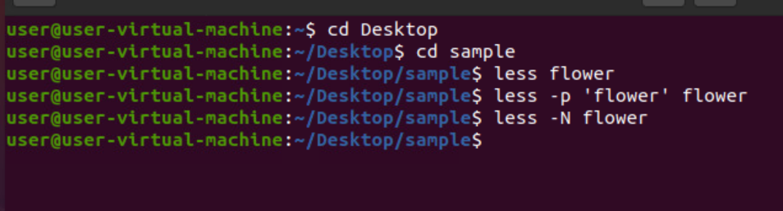

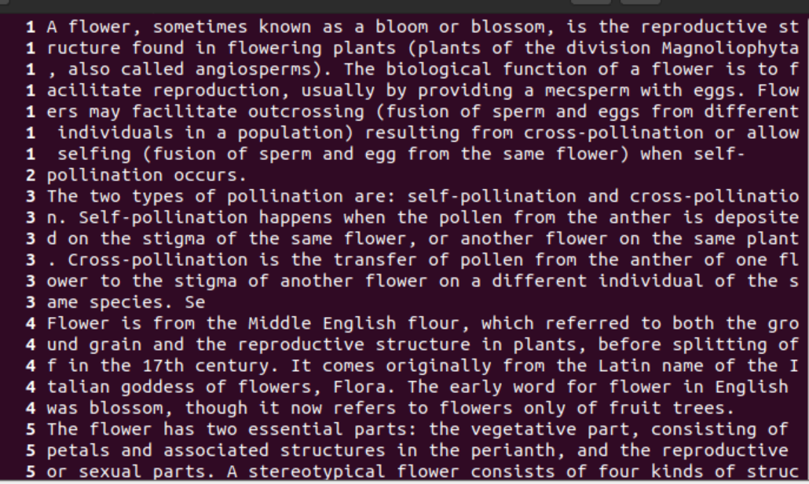

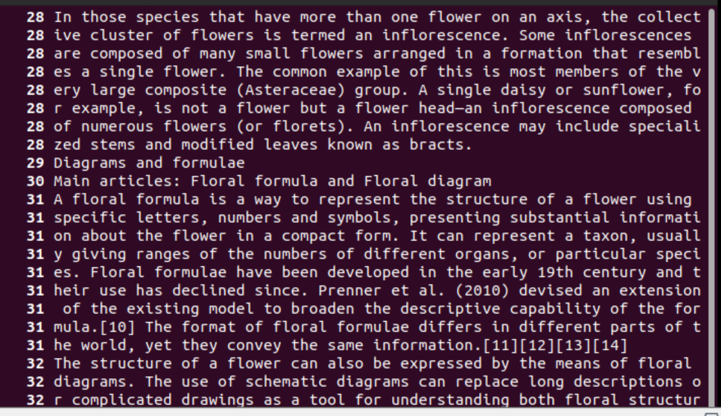

VIM Editor

i | Enter insert mode
Esc | Enter command mode
x or Del | Delete a character
X | Delete character is backspace mode
u | Undo changes
Ctrl + r | Redo changes
yy | Copy a line
dd | Delete a line
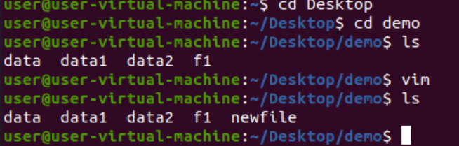

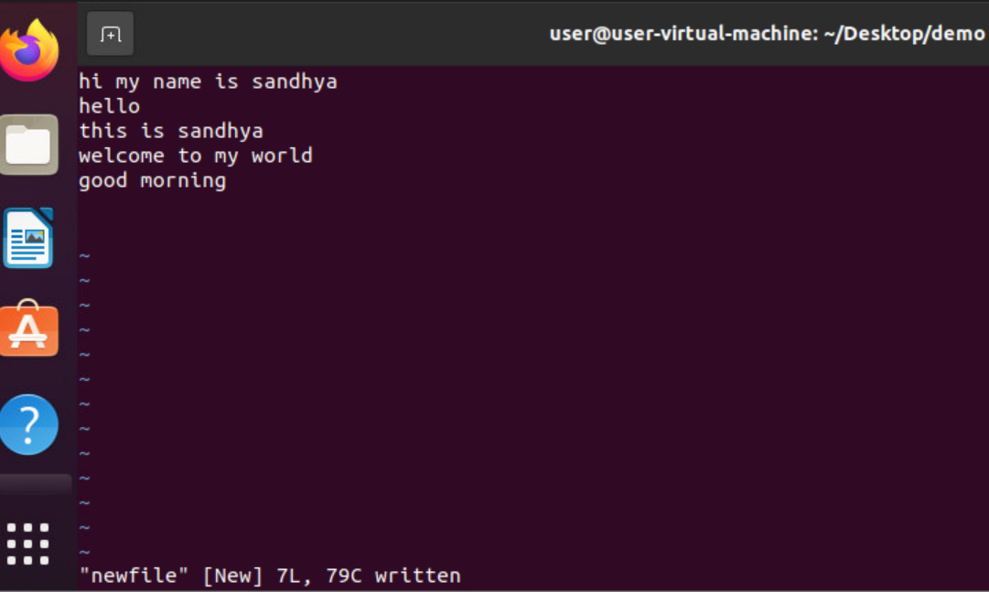

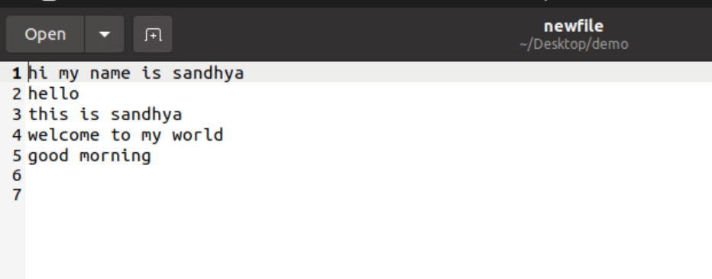

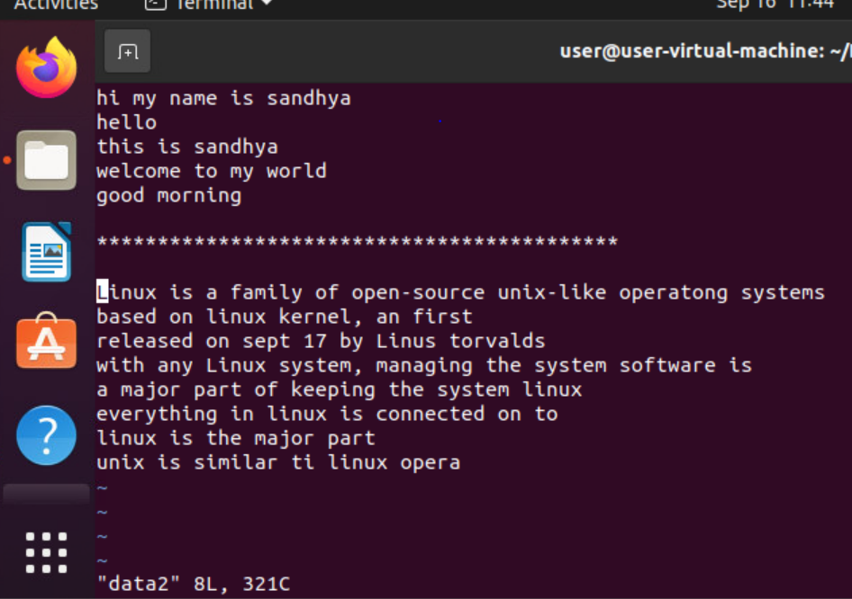Figure 1: Data is copied from Data2 file to newfile

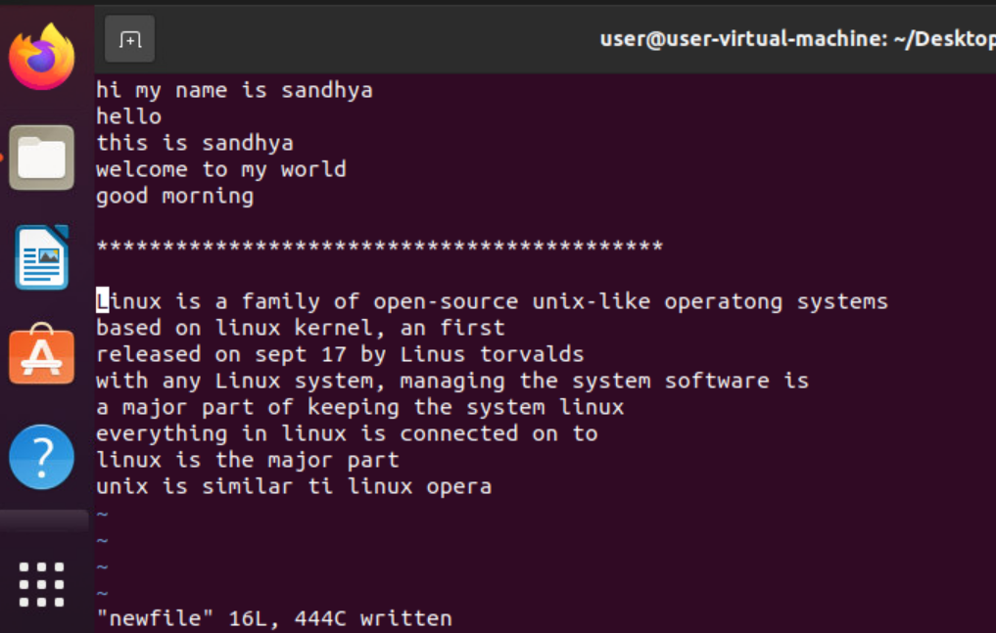Figure 2: Newfile saved after copy

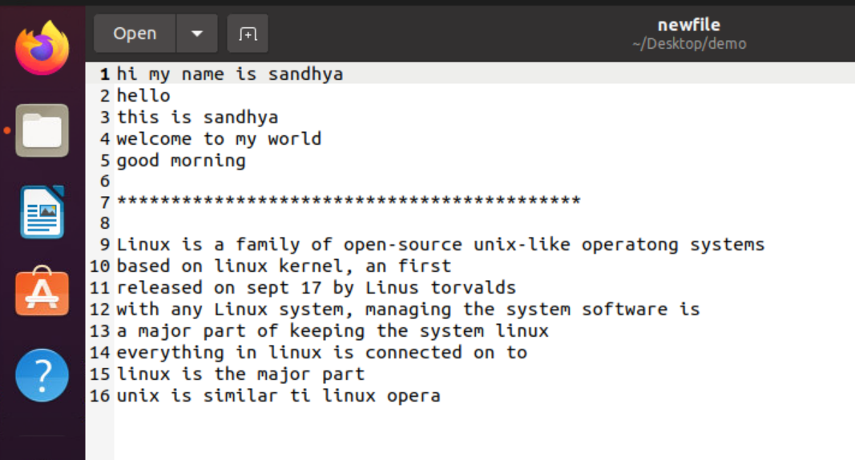Figure 3: Newfile after copy

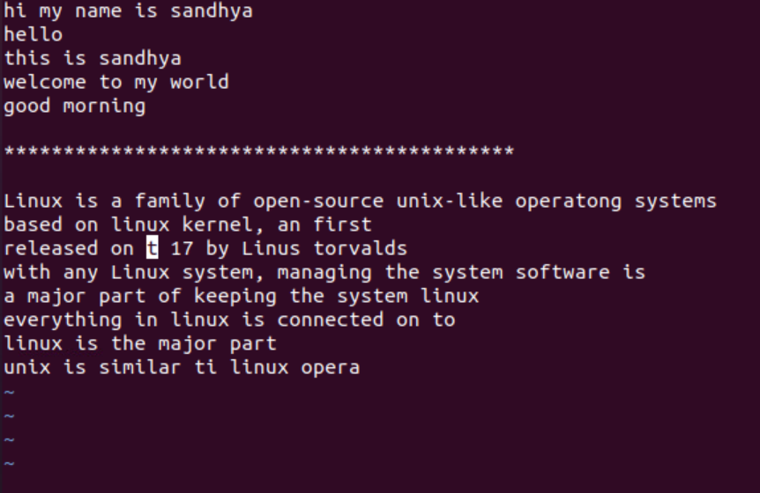Figure 4: 'X' deletes word by word

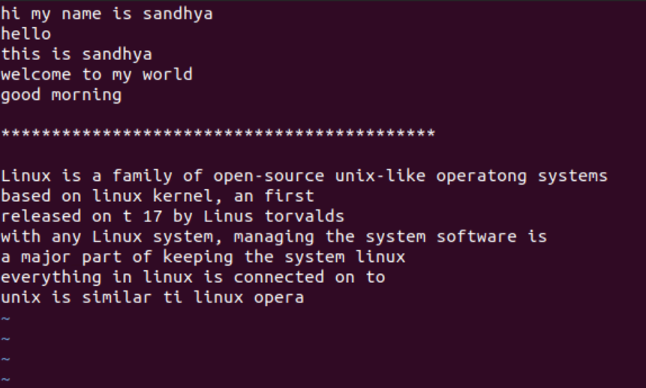Figure 5: 'dd' delete line by line

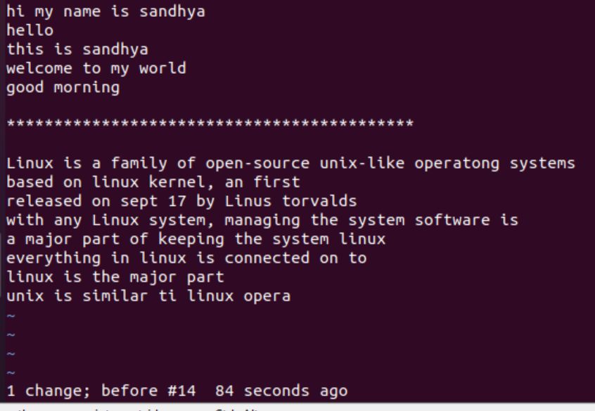Figure 6: 'u' undo

Find, Head and tail commands


